BACK TO THE FUTURE
Lesson 3
A VERY SPECIAL BOOK part 3
Revelation 1:9-20

VI. THE ____________________ OF THE AGE - Vs. 9—20.

A. An age of ___________________ witness — vs. 9.

B. An age of ___________________ worship — Rev. 1:10—18.

We live in two environments. ____________________ & ___________________ — Col. 1:2, To be wrapped up

How could John be in the Isle of Patmos & in the Spirit at the same time? — ________________.
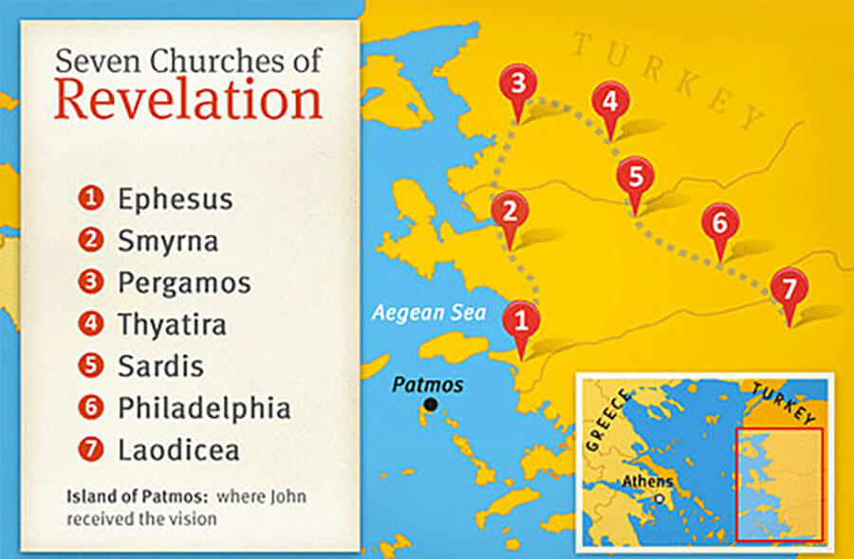

The Book of Revelation is written for each local church.
Each one had a personality.

Ephesus — the ___________________ church; Revelation 2:4.

Smyrna — the ____________________ church; Revelation 2:9.

Pergamos — the __________________ church; Revelation 2:13.

Thyatira — the ___________________ church; Revelation 2:20.

Sardis — the _____________________ church; Revelation 3:1.

Philadelphia — the ________________ church; Revelation 3:8.

Laodicea — the ___________________ church; Revelation 3:15.

He turned to see the voice — vs. 12. And I turned to see the voice that spake with me. And being turned, I saw seven golden candlesticks;

John sees Jesus.
As the ______________________ One — vs. 13. And in the midst of the seven candlesticks one like unto the Son of man, clothed with a garment down to the foot, and girt about the paps with a golden girdle.

As the ______________________ One — vs. 13.

As the ______________________ One — Vs. 14.

As the ______________________ One — Vs. 14.
.
As the ______________________ One — Vs. 15.

As the ______________________ One — vs. 16

As the ______________________ One — Vs. 16.

As the ______________________ One— Vs. 16.

C. An age of ________________________ waiting — Vs. 17—20 And when I saw him, I fell at his feet as dead. And he laid his right hand upon me, saying unto me, Fear not; I am the first and the last: I am he that liveth, and was dead; and, behold, I am alive for evermore, Amen; and have the keys of hell and of death. Write the things which thou hast seen, and the things which are, and the things which shall be hereafter; The mystery of the seven stars which thou sawest in my right hand, and the seven golden candlesticks. The seven stars are the angels of the seven churches: and the seven candlesticks which thou sawest are the seven churches.

He ________________________ John — Fear not.

He ________________________ John — vs. 19—20

